TRENT VALLEY ANGLING
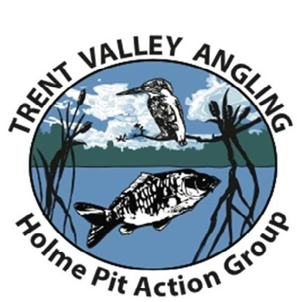
Data Protection Policy to comply with the General Data Protection Regulations (GDPR) 2018
The GDPR became law on 25th May 2018. This means that all organisations, including Trent Valley Angling (TVA), must make their members aware that they keep and store their data (which includes personal information), and members must agree to this.
What data do we hold?
- Members home address, email address and telephone number(s)
- Juniors members (under 18’s) parents and guardians – home address, email address and telephone number(s)
- Members photograph
- Members signature (for the issue of gate keys)
- Members PayPal account details (for membership fee transactions)
- Members name of Bank and Bank account details (for membership fee credit / debit card transactions)
All members are entitled to see their own data that TVA keep and store.
How is the data stored?
TVA stores all the data electronically on a stand-alone computer (not a portable device and/or on a shared server) and all security passwords are known only to the TVA Membership Secretary and the Chairman. All postal applications are scanned and stored electronically and the paper copies are shredded before safe disposal. If a member does not rejoin within 6 months of the membership ending all the data for that member is shredded before safe disposal.
How do we use this data?
The data that TVA keeps and stores is used only for the purpose of managing TVA, including sharing news and other information with its members, and on occasions with other angling organisations for the benefit of TVA members and the betterment of the sport generally.
TVA Management Committee may see membership data but only in connection with TVA membership purposes.
Who else can see it?
TVA has to share some data with other organisations, for example the Angling Trust and The Conservation Volunteers for insurance purposes, for both senior members and junior members (under 18’s). This data refers solely to the total number of TVA members, age range, percentage of disabled members ect, and therefore is not specific to individual members. We will not share the personal data of any individual member with a 3rd party without that member’s permission.
What do you need to do?
If you agree to TVA storing and keeping your data for the above purposes, you do not have to do anything. If you do not agree to TVA storing and keeping your data for the above purposes, please let us know by emailing trentvalleyangling@btinternet.com or by phoning 07976 794880.

